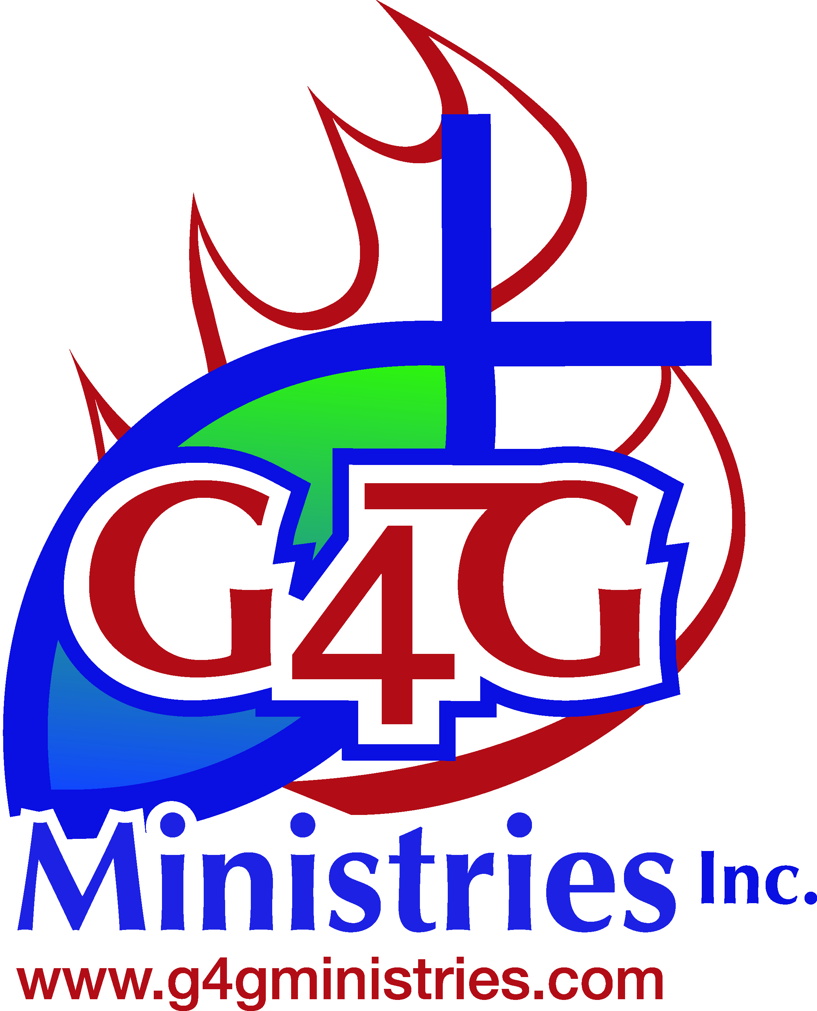
G4G Ministries 13th Annual Golf Entry Form

DATE: October 6, 2023
TIME: Registration opens 11:00am, lunch begins 11:30am, Shotgun starts 1:00pm
PLACE: River Oaks Golf Club - 233 Broken Arrow Dr, Statesville, NC 28677

ENTRY FEE: $100.00 per player (Green fees, cart, lunch, and drinks)
A G4G Ministries WHOLE Chicken goes to the first 100 to register
Payment due September 25, 2023.
Submit payment options: located on the side of the form.

Format: 18 Hole Captains Choice
Contact:
Brad Bullock
Executive Director
Office: 704-380-3708
Cell: 704-818-6488
Email: info@g4gministries.com

Payment option:
Option 1:
Go to https://g4gministries.com/make-a-donation/ and follow instructions for the amount of summary at the bottom of the page.
Option 2:
Print & Fill out Form
Return form & payment to:
2227 Salisbury Hwy
Statesville NC 28677

(If you do not enter a team list, you will be placed with others)

Cancellation Policy: Entry fee is non-refundable.

ENTRY FORM:

NAME:

COMPANY:

ADDRESS:

TELEPHONE:

EMAIL:

Team Members:
Player 1 Name:
Player 2 Name:
Player 3 Name:
Player 4 Name:
# Of Golfers (one entry feeds 25 people) |  | $100
Team (one team feeds 100 people) |  | $400
Platinum (Platinum feeds 750 people) - Logo on the website, mentions in all advertising, event banners with logo, three teams, hole signage & booth space available! |  | $3000
Gold (Gold feeds 500 people) - Logo on the website, mentions in all advertising, two teams, hole signage, & event banners with logo! |  | $2000
Golf Ball Sponsor (feeds 375) - Add logo to golf balls handed out as gifts |  | $1500
Food Sponsor (feeds 300 people) - Logo on the website, mentions in all advertising, team, & hole signage! |  | $1200
Charity Golf Guns Sponsor (250 people) - Logo on the website, team, event banner with logo |  | $1000
Beverage Station (feeds 150) Team & Signage |  | $600
Hole & Team (Hole & Team feeds 150 people) Team & signage |  | $600
Hole (Hole feeds 75 people) Signage: One @ $250 Two @ $300 |  | $300
Mulligans Package |  | $20
 |  | Total
Awards: Team Low Score, Longest Drive, Closest to the Pin, Hole in One Contest

Qty Each Total

